

Lights, Camera, Stocks: Exploring the Impact of Warner Bros. Movie Releases on Stock Market Fluctuations.

|  |  |
| --- | --- |
| **Submitted By: -**  **Rajan Ghimire** | **Submitted To: -**  **Victoria Shtern** |

Introduction 1

Methodology 1

1. Data Collection 1

1. Movie Data Acquisition 1

2. Stock Market Data Retrieval 2

2. Data Processing and Analysis 3

3. Visualization and Interpretation 3

4. Overall Flow: 5

Data Validation: 7

1. Movie Data: 7

2. Stock Data: 8

Analysis of Movie and Stock: 9

1. Furiosa: A Mad Max Saga 9

2. Wonka 10

3. Barbie 12

4. Evil Dead Rise 13

Overall Conclusion: 14

Findings of the Study: 14

# Introduction

The entertainment industry, particularly the film sector, has long been recognized for its potential to influence various aspects of society, including consumer behavior and market trends. This project explores the relationship between movie releases and stock market fluctuations, focusing on the renowned production company Warner Bros. Leveraging data from The Movie Database (TMDb) and Yahoo Finance, we analyze the impact of Warner Bros.' movie releases on the performance of related companies' stocks. By employing sentiment analysis, stock market data analysis, and visualization techniques, this study aims to uncover insights into how blockbuster releases may affect investor sentiment and stock market dynamics. Understanding these dynamics can provide valuable insights for investors, industry stakeholders, and researchers alike.

# Methodology

## Data Collection

Warner Bros. was chosen as the production company for analysis due to its prominence in the entertainment industry and its availability of stock market data on Yahoo Finance. Utilizing the MovieScraper class, movie details were collected from The Movie Database (TMDb) API. This involved downloading information on Warner Bros. movies, including titles, release dates, descriptions, and ratings.

### Movie Data Acquisition

MovieScraper class was used to scrape the data.This class uses TMDb API to get all the movies based on the production company. If set the get_released_only variable to True, it will only give use the released movies before current date.

Class Initialization:   
The class is initialized with an API key required for accessing TMDb:

Method Summaries

1. Get Latest Movies: Fetches the latest movies produced by a specified company.

* Input: company_name (str)
* Output: List of movies or None if the company is not found.

1. Filter Movies by Release Date: Filters out movies that have not been released yet.

* Input: List of movies
* Output: List of released movies

1. Callable Method: Fetches the latest movies and optionally filters for released movies only.

* Input: **company**_name (str), get_released_only (bool)
* Output: List of movies or raises an exception if the company is not found

### Stock Market Data Retrieval

# The StockScraper class was employed to gather historical stock market data for Warner Bros. (NYSE: WB) from Yahoo Finance. Data was collected for a time window spanning from 15 days before each movie's release date to 15 days after, capturing the potential impact of movie releases on stock performance.

# A screen shot of a computer program

## Data Processing and Analysis

The descriptions of Warner Bros. movies were subjected to sentiment analysis using Natural Language Processing (NLP) techniques. Stock market data collected for Warner Bros. was analyzed to identify trends and patterns around the release dates of movies. Visualizations, including plots of stock prices and regression models, were generated to explore correlations between movie releases and stock market fluctuations.

## Visualization and Interpretation

The Visualizer class was utilized to create visual representations of the data analysis findings. This included plotting stock price trends, annotating movie release dates, and visualizing regression models fitted to the stock data.

Class Initialization:

The class is initialized with stock data, producer and movie names, date range, and figure height:

# 

# **Methods of the class:**

# **Plot OHLCV**: Plots the open, high, low, close prices, and volume of the stock data.

# Plot Release Date: Plots stock prices and highlights the movie release date.

# Plot Overall Trends: Plots overall stock price trends and a trend line after the movie release date

# Convert Date: Converts a date string from 'YYYY-MM-DD' format to 'YYYY Month DD' format.

## Overall Flow:

# The scripts are automated and works dynamically by fetching all movies from production company dynamically. Also, the stock analysis is automated. Complete code can be found in this [GitHub](https://github.com/R4j4n/Semester2/blob/main/3334/Assignement%232/RajanGhimire.ipynb).

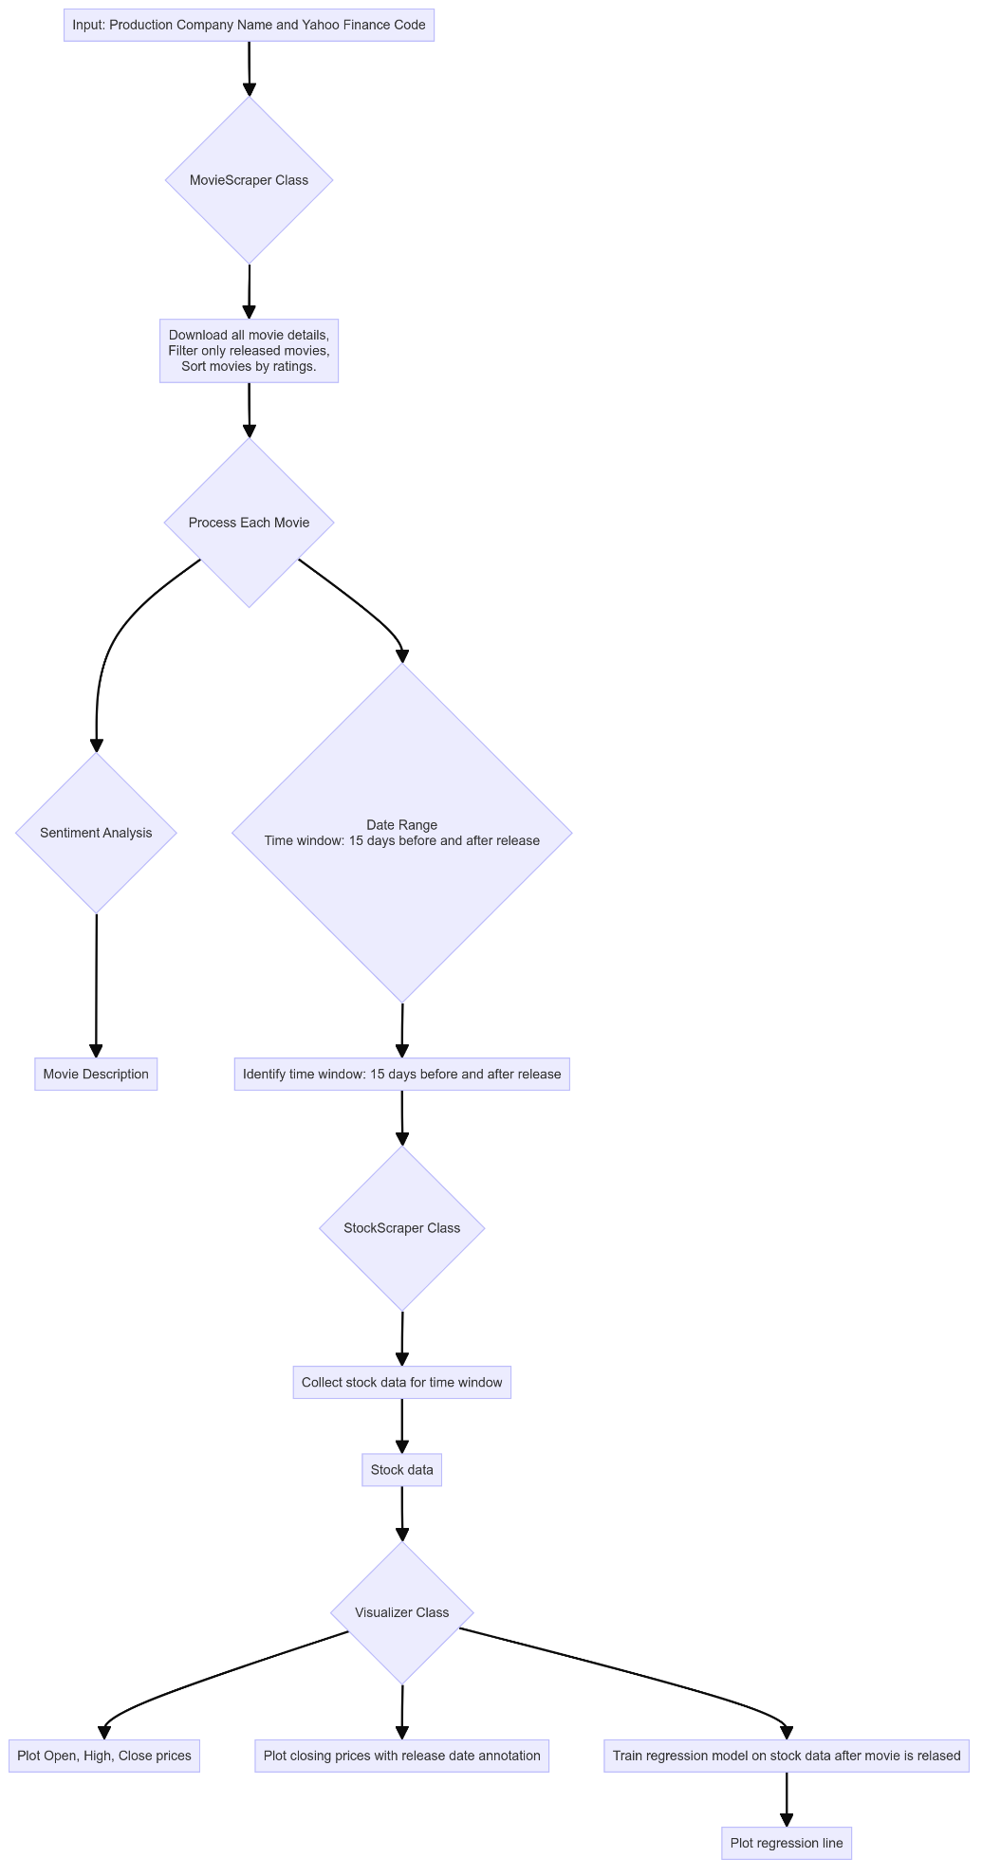

# Data Validation:

## Movie Data:

# These are some of the movies scraped by our code.

# 

And we can validate the movies by looking at the movies listed on TMDB site.

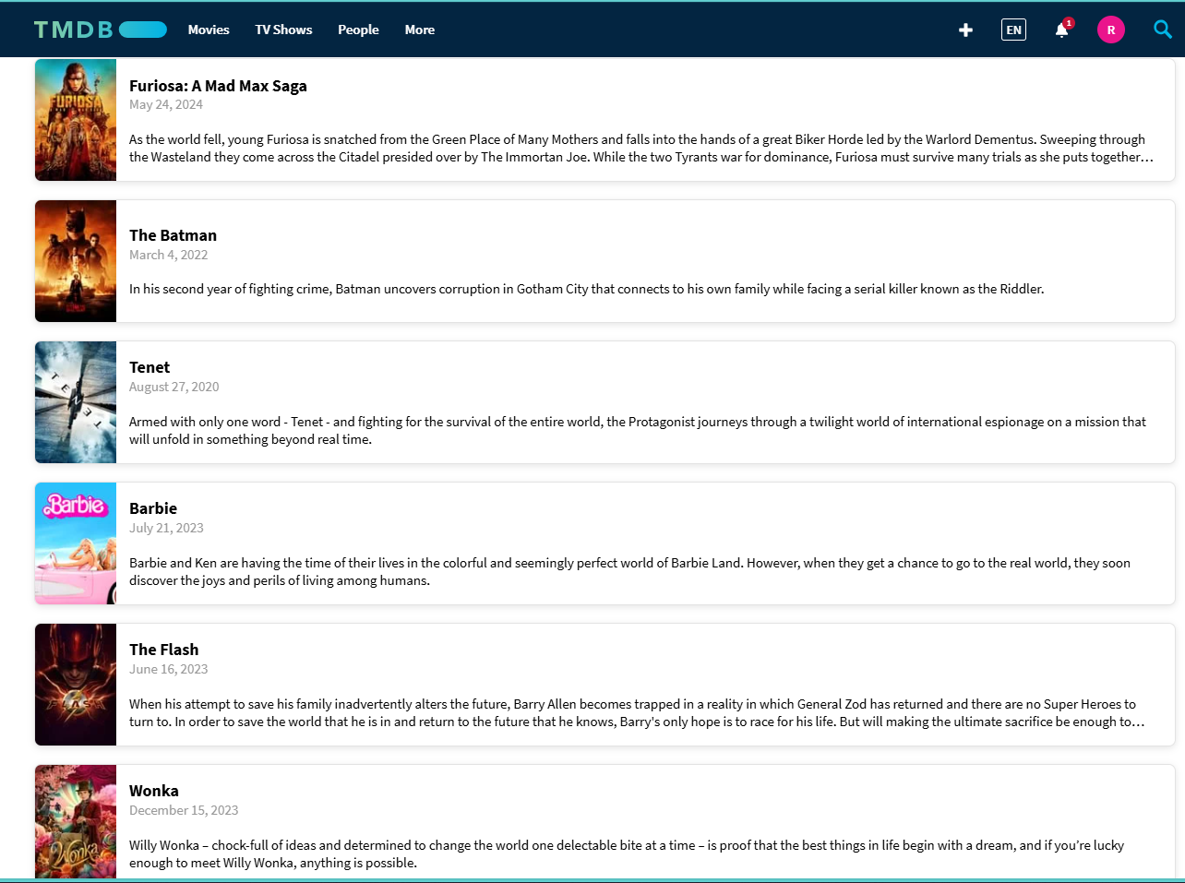

# However, some movies from our API are not present on the TMDB site. Upon further investigation, we discovered that Warner Bros. has several production divisions, such as Warner Bros. Pictures and Warner Bros. Animation. While our API scrapes data from all these divisions collectively, the TMDB site does not list all movies produced by Warner Bros.

## Stock Data:

# When examining Yahoo Finance, Warner Bros. is listed as an active company on the stock market with code **WBD,** which is similar to code that we are using on our code.

# Additionally, the scraped data from our API is complete and contains no missing values.

# Analysis of Movie and Stock:

# For the analysis, here we will only be using the movies that are released before the current date and sort the movies based on their popularity. Since the given code can work with arbitrary number of movies, to keep the document short, I will analyze top 3 movies. Let’s analyze some movies individually:

## Furiosa: A Mad Max Saga

# Here are some information’s about the movie:

|  |  |
| --- | --- |
| Release Date | 2024-05-22 |
| Overall Rating | 7.7 |
| Popularity | 986.382 |
| Movie Overview | As the world falls, young Furiosa is snatched from the Green Place of Many Mothers and falls into the hands of a great Biker Horde led by the Warlord Dementus. Sweeping through the Wasteland they come across the Citadel presided over by The Immortan Joe. While the two Tyrants war for dominance, Furiosa must survive many trials as she puts together the means to find her way home. |
| Sentiment | Positive |
| Stock Analyzed Date | 2024-05-20 -- 2024-05-24 |

# 

# Now, let’s mark the movie release date and let’s see trends in stock with respect to the movie release date.

# This graph presents the closing stock prices of Warner Bros before and after the release of the movie "Furiosa: A Mad Max Saga" on May 22, 2024, marked by the green dashed vertical line

The graphs indicate that stock prices experienced an **upward** trend leading up to the movie release, peaking just before May 22, reflecting growing investor anticipation. Around the release date, there was a **drop** in closing prices followed by some volatility.

## Wonka

# Here are some information’s about the movie:

|  |  |
| --- | --- |
| Release Date | 2023-12-06 |
| Overall Rating | 7.165 |
| Popularity | 286.868 |
| Movie Overview | Willy Wonka – chock-full of ideas and determined to change the world one delectable bite at a time – is proof that the best things in life begin with a dream, and if you’re lucky enough to meet Willy Wonka, anything is possible. |
| Sentiment | Positive |
| Stock Analyzed Date | 2023-12-04 -- 2023-12-08 |

# Now, let’s mark the movie release date and let’s see trends in stock with respect to the movie release date.

# The graph shows a consistent **downward** trend in Warner Bros.' stock prices around the release of "Wonka," with both opening and closing prices decreasing steadily from December 4 to December 7, 2023.

## Barbie

# Here are some information’s about the movie:

|  |  |
| --- | --- |
| Release Date | 2023-07-19 |
| Overall Rating | 7.053 |
| Popularity | 226.105 |
| Movie Overview | Barbie and Ken are having the time of their lives in the colorful and seemingly perfect world of Barbie Land. However, when they get a chance to go to the real world, they soon discover the joys and perils of living among humans. |
| Sentiment | Positive |
| Stock Analyzed Date | 2023-07-17 -- 2023-07-21 |

# Now, let’s mark the movie release date and let’s see trends in stock with respect to the movie release date.

# 

# The graph shows a consistent upward trend in Warner Bros.' stock prices around the release of "Barbie" before and there was rise in stock after movie was launched.

## Evil Dead Rise

# Here are some information’s about the movie:

|  |  |
| --- | --- |
| Release Date | 2023-04-12 |
| Overall Rating | 6.957 |
| Popularity | 91.797 |
| Movie Overview | A reunion between two estranged sisters gets cut short by the rise of flesh-possessing demons, thrusting them into a primal battle for survival as they face the most nightmarish version of family imaginable. |
| Sentiment | Negative |
| Stock Analyzed Date | 2023-04-10 -- 2023-04-14 |

# The graph shows a consistent downward trend in Warner Bros.' stock prices around the release of " Evil Dead Rise " before and after the movie was launched.

# Overall Conclusion:

|  |  |  |  |  |  |  |  |
| --- | --- | --- | --- | --- | --- | --- | --- |
| **Movie Name** | **Release Date** | **Close Price Before** | **Close Price After Release** | **Increase/Decrease** | **Amount** | **Percentage Change** | **Sentiment** |
| Furiosa: A Mad Max Saga | 5/22/2024 | 8.09 | 7.7 | Decrease | -0.39 | -4.82 | Positive |
| Wonka | 12/6/2023 | 11.39 | 10.82 | Decrease | -0.57 | -5 | Positive |
| Barbie | 7/19/2023 | 12.31 | 13.11 | Increase | 0.8 | 6.5 | Positive |
| Evil Dead Rise | 4/12/2023 | 15.4 | 14.04 | Decrease | -1.36 | -8.83 | Negative |

# Findings of the Study:

# Three out of the four movies listed have positive sentiment, but only "Barbie" shows an increase in stock price after its release. This suggests that while positive sentiment might contribute to the success of a movie, it doesn't necessarily guarantee a positive impact on the stock price.

# "Evil Dead Rise" had a negative sentiment and saw a decrease in stock price, which aligns with the sentiment analysis.

# "Barbie" is noted to have generated the most revenue in 2023 and is also the only movie in the table that experienced an increase in its stock price (+0.8, +6.5%). This indicates a possible correlation between high box office revenue and a positive impact on stock prices.